Team 1

Group Leader: Robin Obregon

Scrum-Master: Alejandro Cores

Requirements Leader: Carlos Ramos

Design Leader: Joshua Gomez

Implementation Leader: Brian Rodriguez

Verification Leader: Ivan Najera

CEN4010, Fall 2022

# **Table of Contents**

## Introduction…………………………………………………………………..

* 1. – Description of the Customer/Setting for the Project
     1. – Main Characteristics of the Customer/Sponsoring Organization
     2. – Description of the Main Characteristics of the Application
     3. – Important Contextual Issues/External Constraints on the Application
     4. – Outline of Proposed Schedule for the Project
  2. – Motivation for Selecting this Project
     1. – Team’s Expertise in the Area
     2. – How this Project Could Be Useful in Our Careers

## Requirements………………………………………………………………..

* 1. – Define Requirements Elicitation
  2. – Requirements Elicitation Process
  3. – Five Major Features
  4. – User Stories
  5. – Detail Specific Requirements
     1. – External Interface Requirements
     2. – Functional Requirements
     3. – Nonfunctional Requirements

## Design………………………………………………………………………..

* 1. – Design Constraints
  2. – Define Design
  3. – Design Process Introduction
  4. – Graphical Representations of the Design
     1. – Use Cases
     2. – Application Flow Chart
     3. – Sequence Diagrams
  5. – Design Process Attributes
     1. – Class Diagrams
     2. – Conceptual Database Design
     3. – Relational Database Schema
     4. – Architectural Design
     5. – Screen Mock-Ups
  6. – Rationale Management
     1. – Issues Addressed
     2. – Alternatives Considered
     3. – Decisions Made to Resolve the Issues
     4. – Criteria Used to Guide Decisions
     5. – Debate Regarding Decision-Making

## Implementation………………………………………………………………

* 1. – SCRUM Methodology
  2. – Daily Standups

## Verification…………………………………………………………………...

* 1. – Verification Definition
  2. – Verification Process Introduction
  3. – Test Case Description/Demonstration
  4. – Traceability Between the Test Cases/Plan and Requirements

## Lessons Learned……………………………………………………………

# **1. Introduction**

## 1.1: Description of the Customer/Setting for the Project

1.1.1: Main Characteristics of the Customer/Sponsoring Organization

The demographic of this application would be students who do not have experience planning and setting up a routine. Universities and colleges that will utilize this tool for organizational purposes and event planning. Third party software companies that use the ScheduleMe platform for collaboration and marketing. The setting will be an online website that hosts and connects to diverse platforms.

1.1.2: Description of the Main Characteristics of the Application

Our application aims to provide assistance to the time management problems that students face throughout their academic experience. Scheduling could be a daunting and overwhelming task, so it would be nice if a program broke this task down into simple steps for us, and kept us organized and notified like a mini personal secretary.

This application is different from schedule/calendar applications that already exist because other applications such as google calendar are built for any general use; therefore, they require additional work to set up the application to be organized around an individual's responsibilities. Since our program is built for students, users will not need to do any additional organizational work since the program would do that for them. Specifically, users could label events under predefined categories (which class it corresponds to, whether it’s an assignment/test/class time), and they could specify the priority of events.

Additionally, our program would provide a dashboard that provides an overview of events that come from the user’s courses (or user created categories). This dashboard would list important dates of tests, projects, and assignments. The dashboard would also help students plan accordingly for these deadlines by providing recommendations of different study plans. The feature to share schedules in a pdf format or directly through the app would also be available for students to work more cohesively with peers in projects, or plan social events with their friends whenever they are free.

The implication of this tool is that it could decrease the user’s stress due to better time management and being on top of their responsibilities. The application should have the side product of preventing procrastination by reminding the user about their schedule which would give them additional free time. Finally, it would be helpful for students who do not have experience in scheduling to develop time management skills without becoming overwhelmed.

1.1.3: Important Contextual Issues/External Constraints on the Application

The program is only catered for students and is impractical for people other than students to use. Additionally this implies that once a user is no longer a student they will most likely stop using the application.

1.1.4: Outline of Proposed Schedule for the Project

## 1.2: Motivation for Selecting this Project

1.2.1: Team’s Expertise in the Area

As college students, it is evident that everyone in the team has had multiple experiences with time management issues. The path to becoming a well-balanced student is one that a lot of people pursue. However, not many people have the discipline to create and adhere to a routine that properly balances all their life aspects. Despite the fact that none of us are qualified mental health professionals, being part of the demographic we are targeting allows us to, in a way, reverse engineer the application and its functionality.

1.2.2: How this Project Could Be Useful in Our Careers

Time management is a skill that we are far from perfecting. Developing a scheduling software specifically made to help us be more organized and up to date with our courses would evidently be beneficial. Moreover, there is a high chance that a majority of us become software engineers after graduating. Not only do we obtain a deep insight on the functionality of SCRUM methodology, but we also gain experience developing software as a team.

# **2. Requirements**

## 2.1: Define Requirements Elicitation

* Includes all the same functionalities as a calendar
* Gives recommendations on how the student should allocate their time
* Make sharing the schedules of two people easier

## 2.2: Requirements Elicitation Process

The first stage of the elicitation process had the goal of deciding the main purpose of our software. We brainstormed different problems that we thought FIU students or any other demographic faced. Once we had a list of problems that we found important as a group we decided to focus on a software that would help with time management and mental health through the organization of a calendar.

Requirement discovery: In this stage our team created a list of possible features that would be useful to fulfill the purpose of our application. Since university students are the main demographic for our software most features came out of the thoughts of our group members and our peers.

Requirement classification and organization: After looking at the list features that we would like to include in our software we sorted them into five categories: Main calendar features, mental health features, Social Features, Account features, and miscellaneous features. We would like our users to have the utility of a calendar along with additional aid to help them maintain their schedule. Additionally, we would like our program to include some social capabilities for our users to be able to share their schedules with others. Our software

Requirement prioritization and negotiation: Given the short time constraint and difficulty of creating this software, our team decided on creating mockups to illustrate how the software would function if it were implemented. Also, due to the time limit we decided to not prioritize some other miscellaneous features, such as a music recommendation feature, in order for our time to be focused on the development of the more central features of our program.

Requirement specification: The creation of our features were done by elaborating on the viewpoint on how our users would use them.

## 2.3: Five Major Features

1. Users are able to login and save their calendar on our database. This allows them to access their calendars from any device as long as it has internet connection and a browser.
2. Dashboard that displays high priority events, and depending on the type of event it could give recommendations on what times should be allocated to correctly prepare for an event.
3. Users can specify their school or university and the public calendars of all the organizations in the school should be available to be added into one's schedule.

1. The program has a social network which allows users to share their own calendars with others. Here users are able to friend each other and share their schedules.
2. A page to display the users currently saved calendars that provides different views (e.g. day, week, month, year).

## 2.4: User Stories

Story Number/ID: **SM01**

Title: Customizable Notifications **(Calendar Feature)**

Description As a user, I want to be able to customize my notification settings

Acceptance Criteria

|  |  |  |  |
| --- | --- | --- | --- |
| AC # | Given | When | Then |
| 1 | I am a user | I go into the site settings | There will be an option to select an event or task. |
| 2 | “ “ | I select the event | I will be able to select when and how to notify me. |
| 3 | “ “ | I select an option | I will be able to receive notifications via email and/ or text. |
| 4 | “ “ | I select another option | I will be able to select the date of notification and/or frequency. |

Story Number/ID: **SM02**

Title: Mindfulness Tasks **(Mental Health Feature)**

Description: As a user, I want to be able to set up a relax/break session.

Acceptance Criteria

|  |  |  |  |
| --- | --- | --- | --- |
| AC # | Given | When | Then |
| 1 | I am a user | I access the calendar | There will be an option to add an event or task. |
| 2 | “ ” | I select an event | I will be able to create a mindfulness task. |
| 3 | “ ” | I select a task | I will be able to set when to perform the task. |
| 4 | “ ” | I select to perform task | I will be provided with options to be redirected (i.e. Calm, HeadSpace, Spotify, etc.) |

Story Number/ID: **SM03**

Title: Event Labeling **(Calendar Feature)**

Description: As a user or organization, I would like to be able to label the events on my calendar.

Acceptance Criteria

|  |  |  |  |
| --- | --- | --- | --- |
| AC # | Given | When | Then |
| 1 | I am a user | I create an event | There will be an option to name the event. |
| 2 | “ ” | I am editing an event | I can change the name of the event. |
| 3 | I am an organization | I create an event | There will be an option to name the event. |
| 4 | “ ” | I am editing an event | I can change the name of the event. |

Story Number/ID: **SM04**

Title: Event Hierarchy **(Calendar Feature)**

Description:  As a user or organization, I would like to be able to tier the events on my calendar in order of importance.

Acceptance Criteria

|  |  |  |  |
| --- | --- | --- | --- |
| AC # | Given | When | Then |
| 1 | I am a user | I create an event | I can give it a certain tier of importance (i.e. not important, moderate importance, very important). |
| 2 | “ ” | I am editing an event | I can change the tier of importance. |
| 3 | I am an organization | I create an event | I can specify whether the event is mandatory or elective. |
| 4 | “ ” | I am editing an event | I can change whether the event is mandatory or elective. |

Story Number/ID: **SM05**

Title:Document Parsing **(Calendar Feature)**

Description: As a user, I would like to log important dates or events from a document into the calendar.

Acceptance Criteria

|  |  |  |  |
| --- | --- | --- | --- |
| AC # | Given | When | Then |
| 1 | I am a user | I access the calendar | I can submit a document to the app. |
| 2 | “ ” | I am editing an event | I can obtain information from a submitted document. |

Story Number/ID: **SM06**

Title: Plan Assistance **(Mental Health Feature)**

Description: As a student, I would like to perform better in my school courses / extracurriculars. activities.

Acceptance Criteria

|  |  |  |  |
| --- | --- | --- | --- |
| AC # | Given | When | Then |
| 1 | I am a student | I create/edit an event relating to a school assignment/exam | A prompt offering study plans will appear. |
| 2 | “ ” | I ask the app to provide me with studying assistance. | App will suggest study plans out of which the student will pick one based on convenience. |
| 3 | I am a student athlete | I create/edit an event relating to the current sport season I’m partaking in. | App will provide possible training programs/schedules. |

Story Number/ID: **SM07**

Title:Social Profile Creation **(Social Network Feature)**

Description: As a user, I would like to create a social profile with a picture and biography.

Acceptance Criteria

|  |  |  |  |
| --- | --- | --- | --- |
| AC # | Given | When | Then |
| 1 | I am a user | I wish to create a profile | App asks me to input my name and biography. |
| 2 | “ ” | I choose to update a profile picture. | The app prompts me to choose a picture from my local device. |
| 3 | “ “ | I ask the app to connect with  friends. | The app will suggest friends within my contacts. |
| 4 | “ “ | I ask the app to disconnect with friend. | The app will show the friend that you disconnected. |

Story Number/ID: **SM08**

Title: Calendar Sharing **(Social Network Feature)**

Description:

Acceptance Criteria

|  |  |  |  |
| --- | --- | --- | --- |
| AC # | Given | When | Then |
| 1 | I am a user | I ask the app to share my calendar. | The app asks me which friend to share with. |
| 2 | “ “ | I ask the app to unshare my calendar. | The app unshares the calendar. |
| 3 | I am a user | I create a comment in a shared calendar. | The comment is displayed to everyone the calendar is sharing to. |

Story Number/ID: **SM09**

Title: Calendar Extraction **(Calendar Feature)**

Description:

Acceptance Criteria

|  |  |  |  |
| --- | --- | --- | --- |
| AC # | Given | When | Then |
| 1 | I am a user | I ask the app to extract my calendar. | The app displays which format I would like to extract it with. |
| 2 | “ “ | I ask the app to extract a shared calendar. | The app displays which format I would like to extract it with. |

Story Number/ID: **SM10**

Title: **Introduction Survey (Mental Health Feature)**

Description: As a student, I will be answering questions from a survey whether the app is helpful for my mental health.

Acceptance Criteria

|  |  |  |  |
| --- | --- | --- | --- |
| AC # | Given | When | Then |
| 1 | I am a student | Survey will appear in the Main page once I log in. | I will be able to answer if the app is causing me stress or not. |
| 2 | “ “ | Specify what are the pros and cons of the app. | What improvement should the app make to cause less stress. |

Story Number/ID: **SM11**

Title: Calendar creation **(Calendar Feature)**

Description: Calendar in this instance does not mean a display of all the days in a year but a set of events that a user can specify

Acceptance Criteria

|  |  |  |  |
| --- | --- | --- | --- |
| AC # | Given | When | Then |
| 1 | I am a user | I click on the create button and chose create calendar | I will be prompted a window that would let me specify certain attributes of the calendar |
| 2 | “” | I am prompted the window to create a calendar | I can specify the privacy of the calendar (public, private, or only available to certain users) |
| 3 | “” | I am prompted the window to create a calendar | I can choose the color of the calendar |
| 4 | “” | I am prompted the window to create a calendar | I can choose the name of the calendar |
| 5 | “” | I am promoted the window to create a calendar | I should have the option to alter the default settings of notifications of all the events in the calendar |
| 6 | “” | I am prompted the window to create a calendar | I can change the default priority of all the events in the calendar. |

Story Number/ID: **SM12**

Title: Event creation **(Calendar Feature)**

Description: A user or an organization can add events into calendars. Events are labeled allocated time that can overlap with other events.

Acceptance Criteria

|  |  |  |  |
| --- | --- | --- | --- |
| AC # | Given | When | Then |
| 1 | I am a user | I click on the create button | I should be able to choose to create an event. If I chose to create an event a window should pop up that will allow me to specify more information |
| 2 | “” | The event creation window appears | The user should be able to add a title to the event |
| 3 | “” | The event creation window appears | The user should be able to specify which calendar this event corresponds to |
| 4 | “” | The event creation window appears | The user should be able to specify the location of the event |
| 5 | “” | The event creation window appears | The user is able to specify the day and the time interval that the event is occurring |
| 6 | “” | The event creation window appears | The user is able to state that the event is occurring all day |

## 2.5: Detail Specific Requirements

2.5.1: External Interface Requirements

* User is required to login to view and access app functionalities.
* If the user does not have an account, the sign-up screen would guide the user through the profile creation process.
* Once logged in, the user would have a view of their current calendar and would be able to access the dashboard.

2.5.2: Functional Requirements

**Calendar:**

* A drop-down menu that is able to toggle through different calendar views, day, week, month, year.
* Users should be able to create Calendars. Calendars can be thought of as containers which characterize events.
* Users should be able to modify Calendar attributes. Attributes include the privacy of a Calendar, whether it is public or private and who has the permissions to see it, the color of the Calendar, and the default priority of events in that category.

**Social Features:**

* Users are able to friend one another.
* Users are able to view their friends list.
* Users can set their university status to their current university.
* Users can save calendars from organizations and universities.

**Mental health/Productivity:**

* Users can view a dashboard to see upcoming important events. The user can click on events in this dashboard to receive guidance on how to plan for this event.
* Users have an option to set a goal which they want to accomplish and the program could recommend appropriate time slots for this goal.
* When setting a goal the program would guide the user to make smaller milestones to make progress towards the goal possible.
* The program can parse documents to and create a calendar filled with events based on that document.
* Users have the option to set on notifications for certain calendars or events.
* Users can set how early they would get notifications.
* Users can choose to receive notifications through email, text message, or through the application.

**Miscellaneous:**

* Data encryption.
* Terms and Conditions.
* Email Verification.
* Store User Data.

2.5.3: Nonfunctional Requirements

* Each page must load within 2 seconds.
* The system must meet the web contact accessibility guidelines.
* System uptime of at least 95%.
* Reliability, availability, and maintainability of the database.
* Durability. After a transaction completes successfully, the changes it has made to the database persist, even if there are system failures.
* Only 100 transactions can be performed simultaneously.

# **3. Design**

## 3.1: Design Constraints

* Recouping funds to develop the web platform.
* Time constraints and conflicting schedules of the development team members.
* Hardware limitations and compatibility with other services.
* Negotiation of business partnerships with related target ideas.

## 3.2: Define Design

Software design is the process of defining software methods, functions, objects, and the overall structure and interaction of your code so that the functionality will satisfy users requirements. Software design is the first step in the Software Design Life Cycle, which moves the concentration from problem domain to solution domain. It tries to specify how to fulfill the requirements mentioned in the Software Requirement Specification document.

## 3.3: Design Process Introduction

ScheduleMe is based on the Model-View-Controller (MVC) architectural design. The MVC design pattern divides the application into three major components: Model, View, and Controller. The Model is the backend that contains all the data logic. The View is the frontend or graphical user interface (GUI) which the end user sees. The Controller is the brains of the application that controls how data is displayed.

## 3.4: Graphical Representations of the Design

3.4.1: Use Cases

3.4.2: Application Flow Chart

3.4.3: Sequence Diagrams

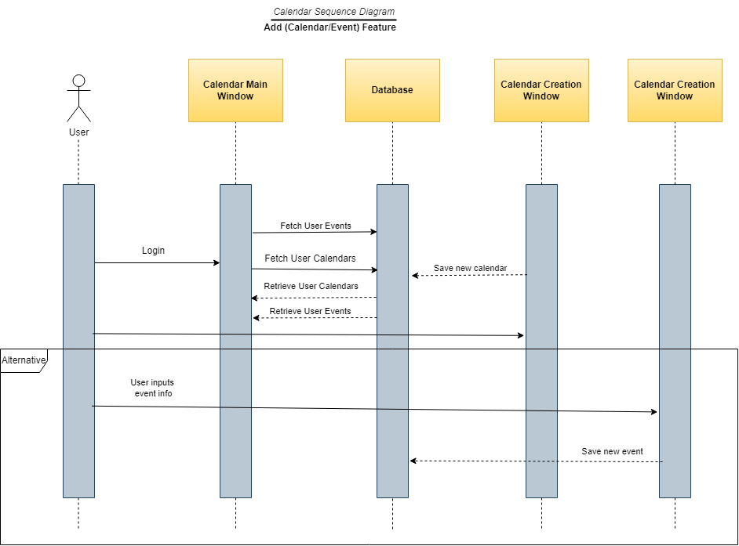

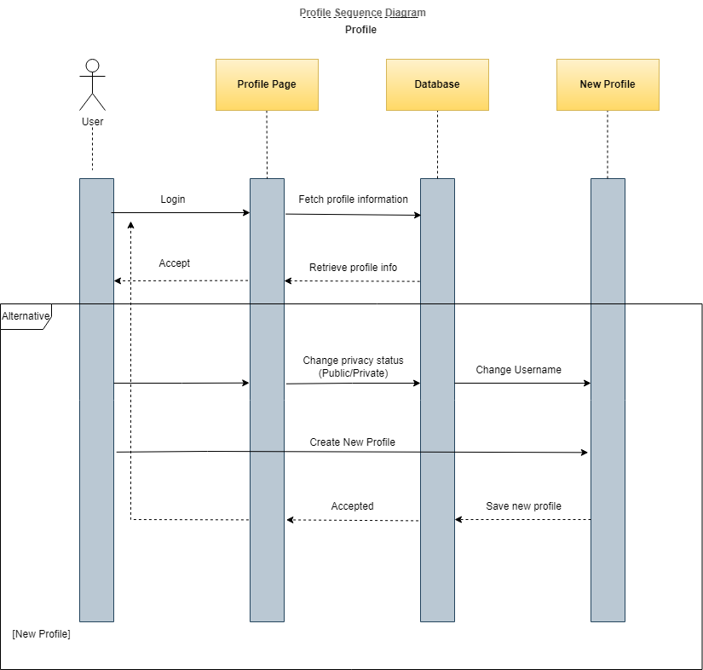

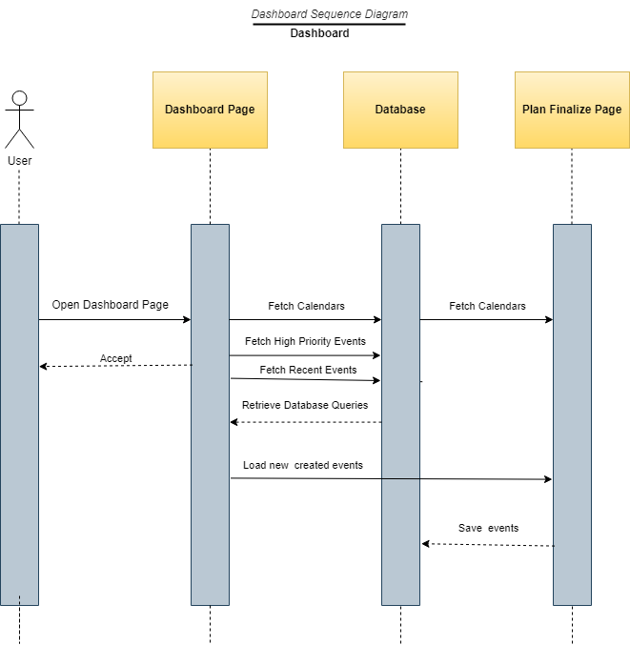

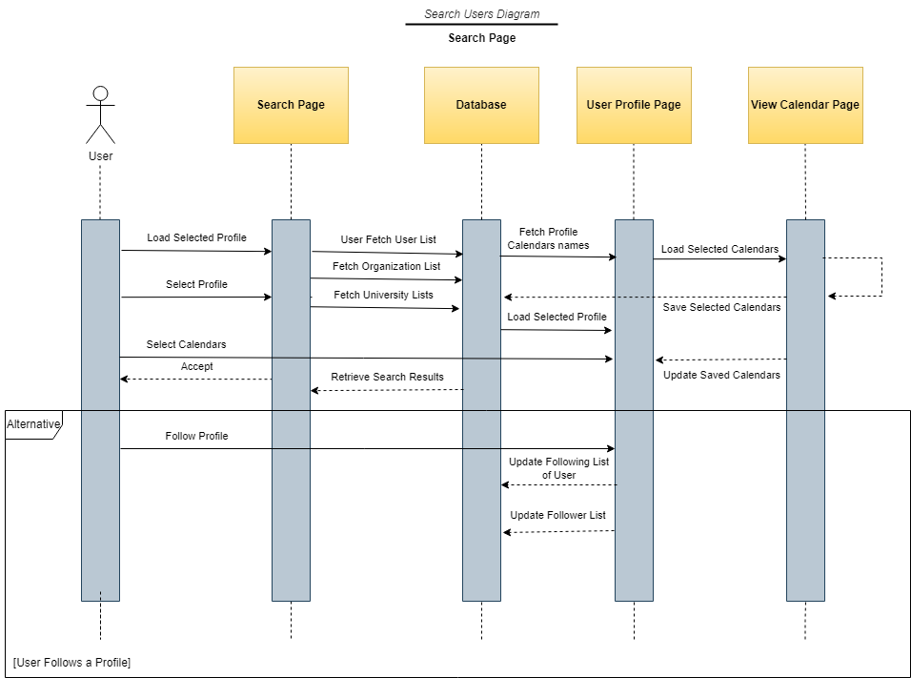

## 3.5: Design Process Attributes

3.5.1: Class Diagrams

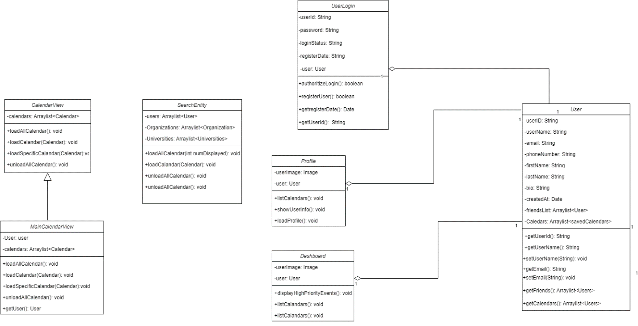

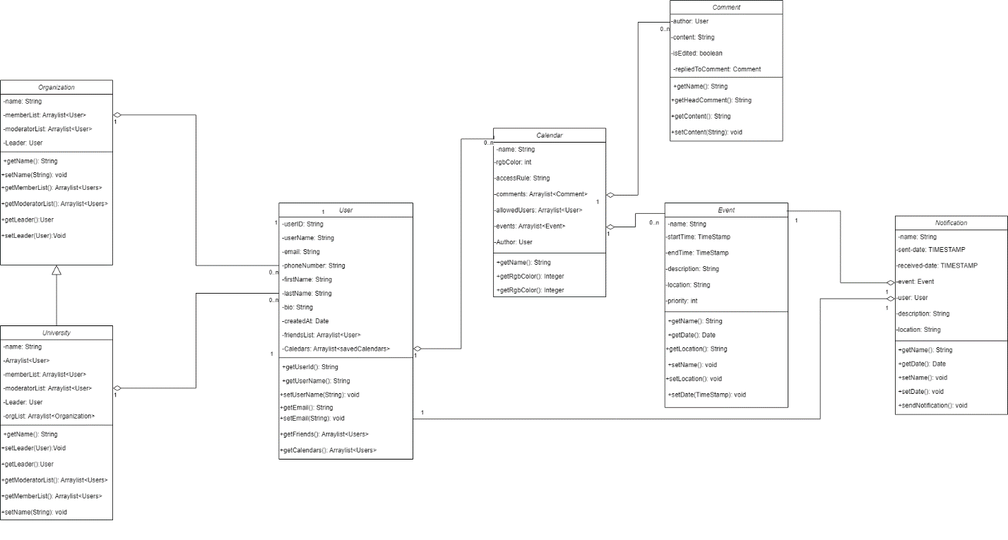

3.5.2: Conceptual Database Schema

3.5.3: Relational Database Schema

**Organizations Page**

**Calendar Page**

**Complete Database Diagram**

3.5.4: Architectural Design

3.5.5: Screen Mock-Ups

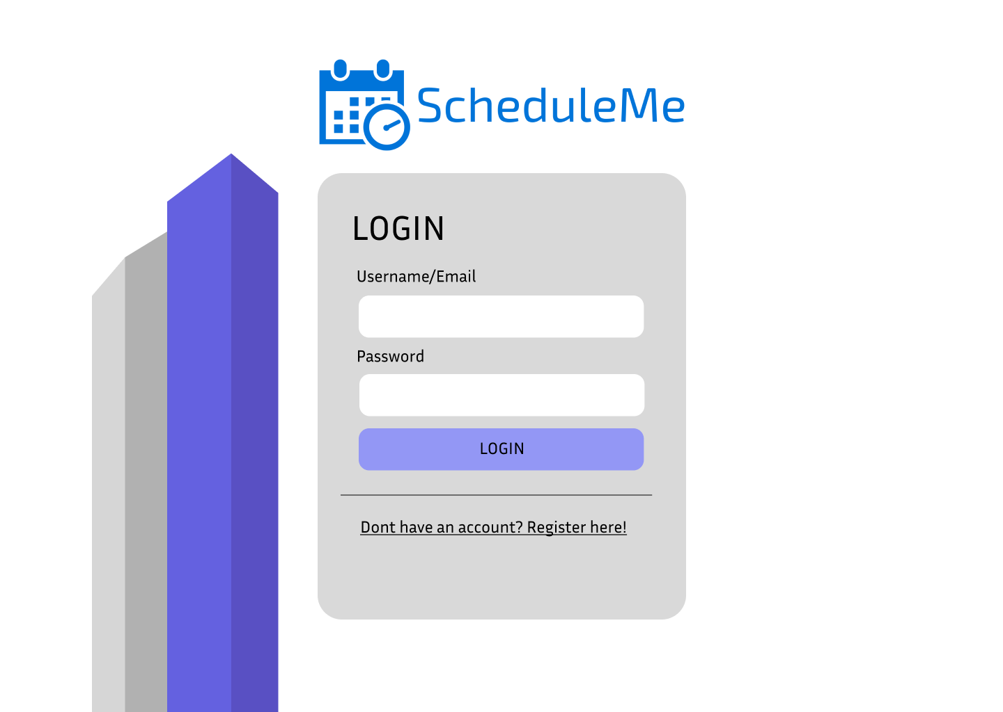

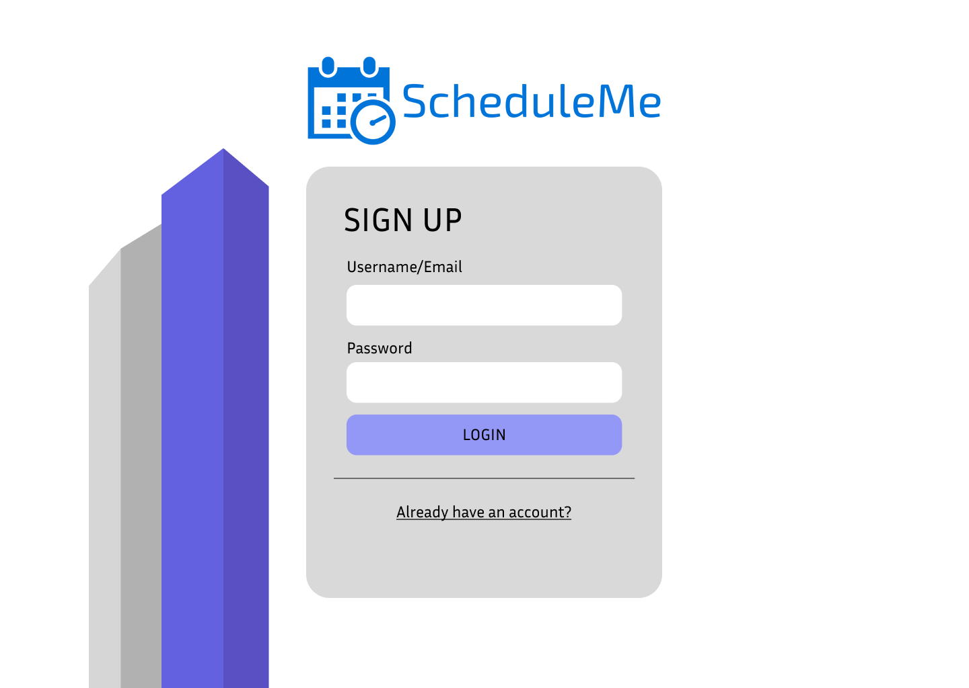

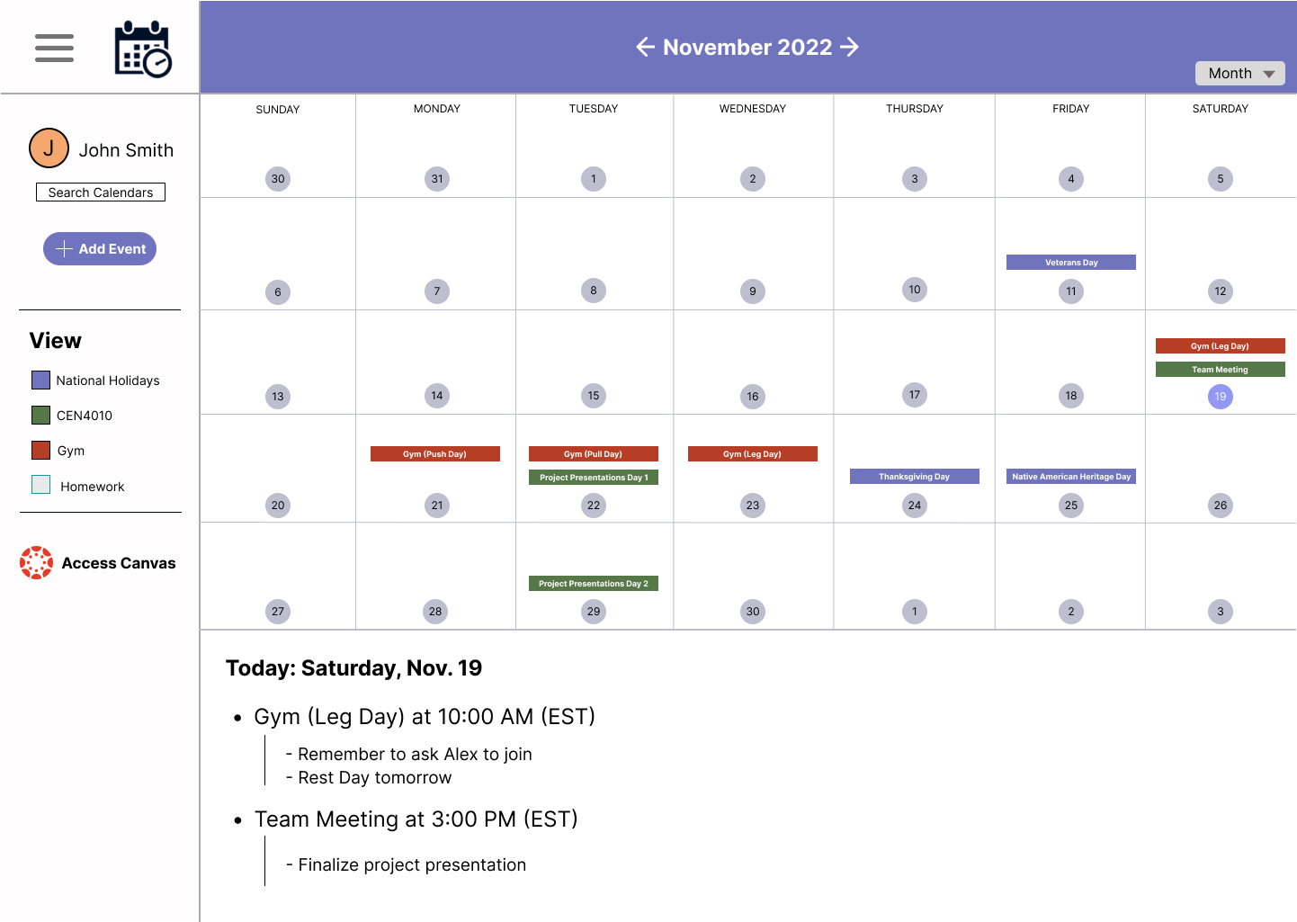

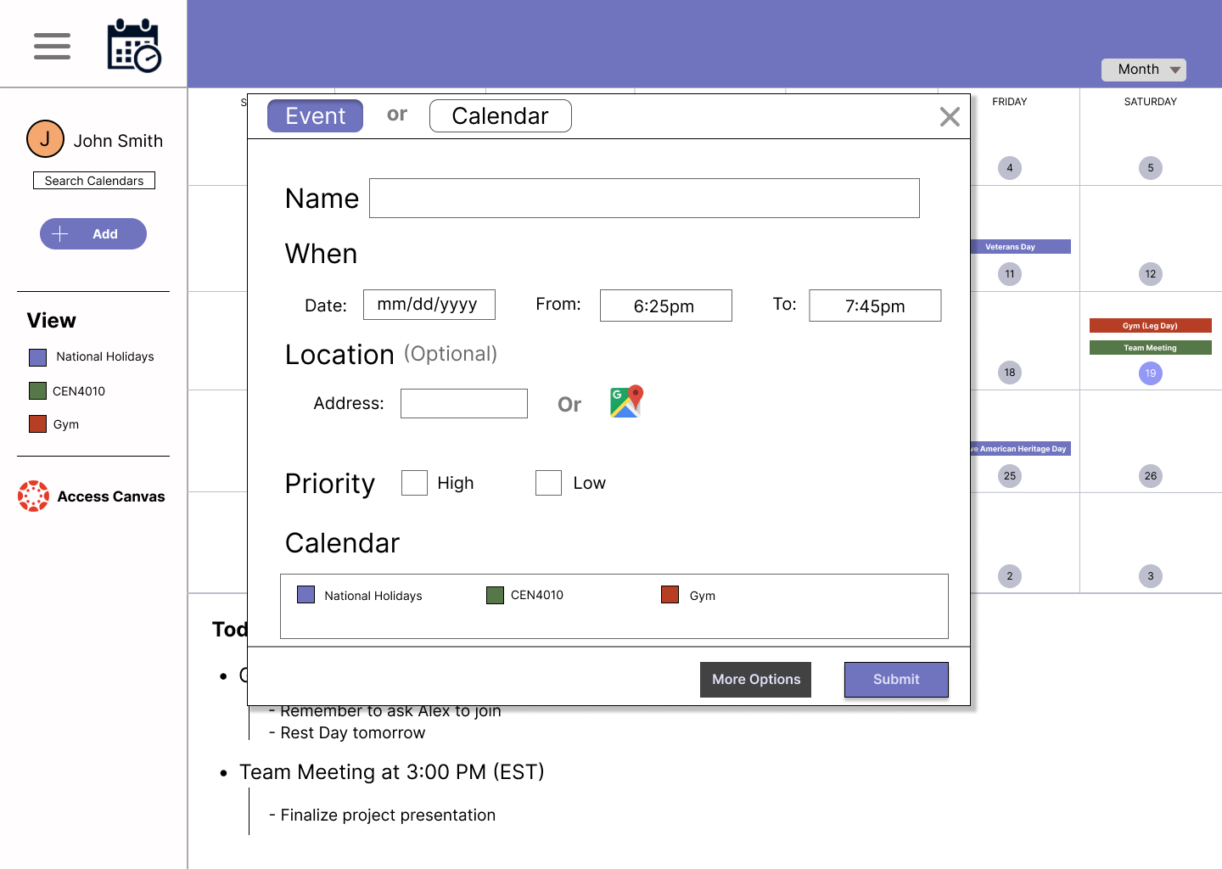

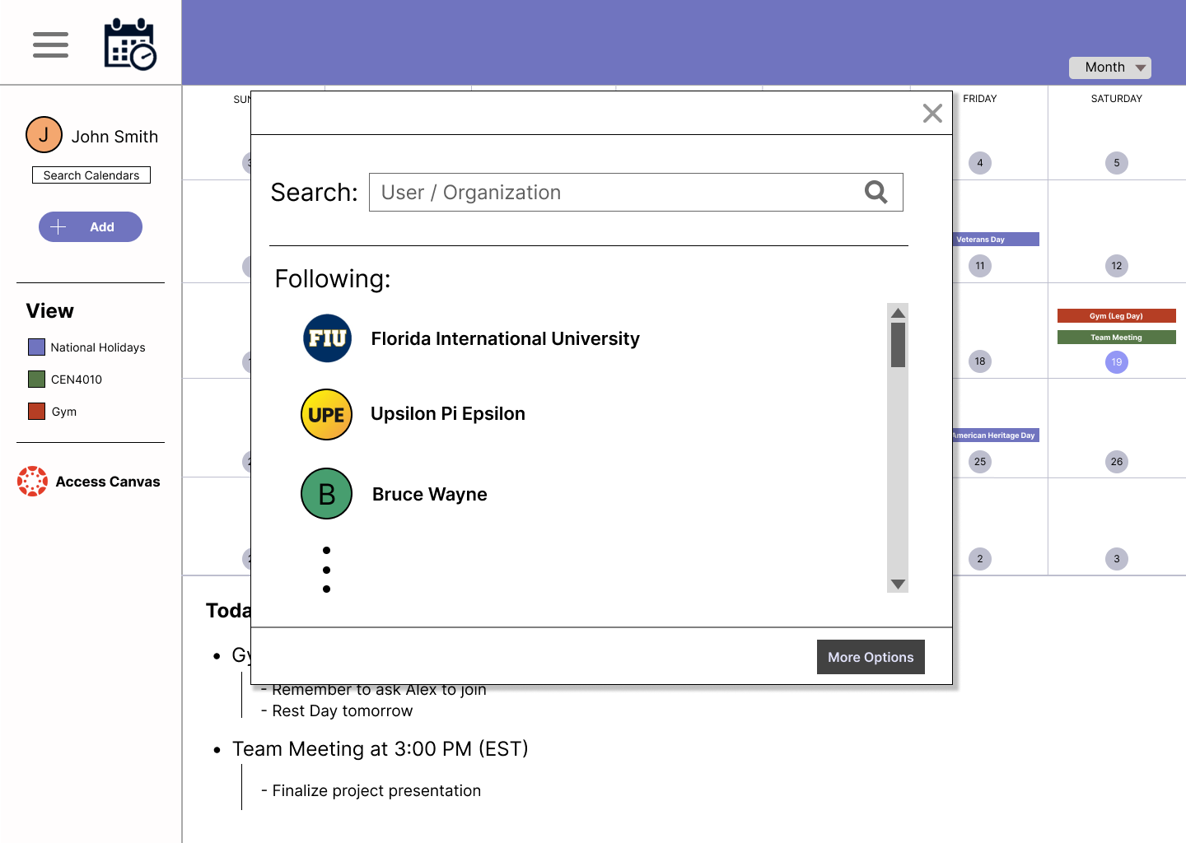

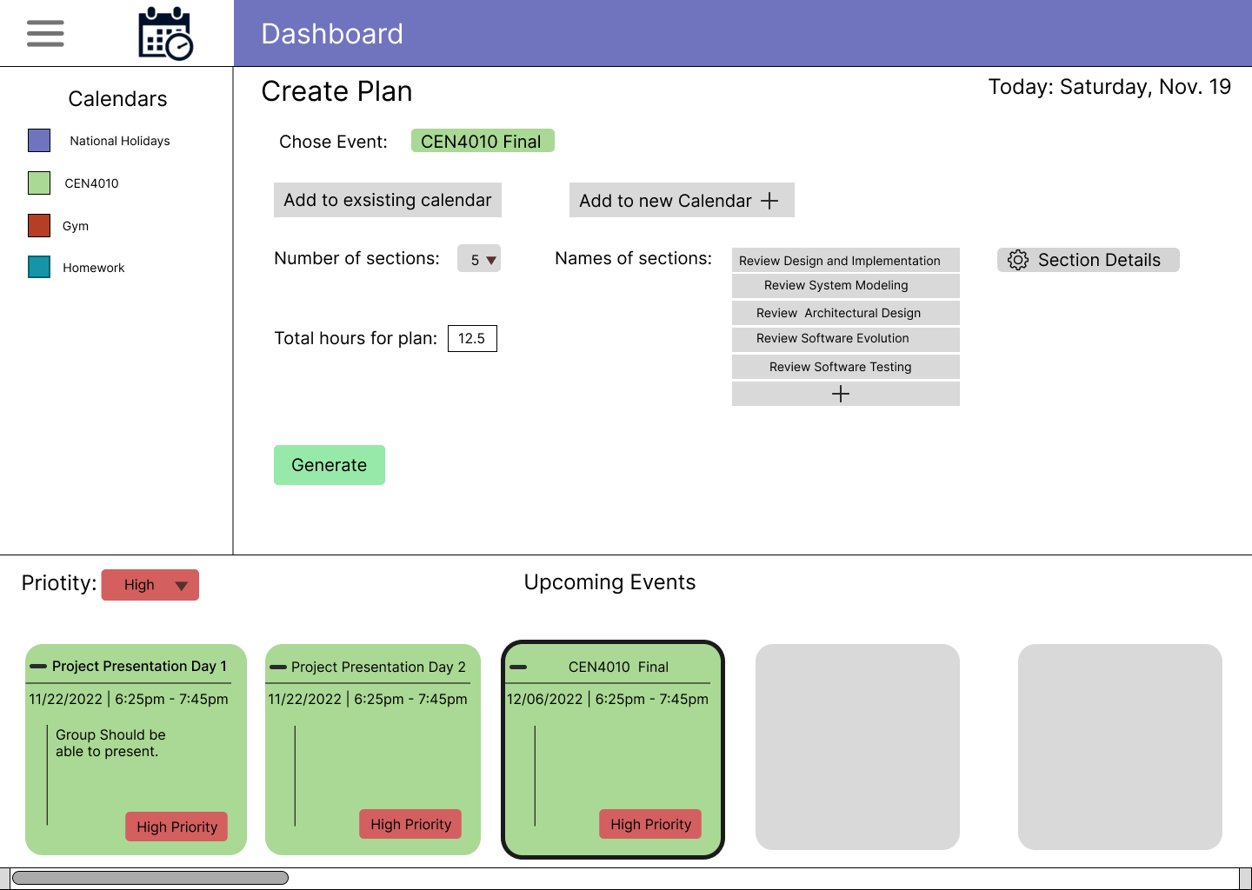

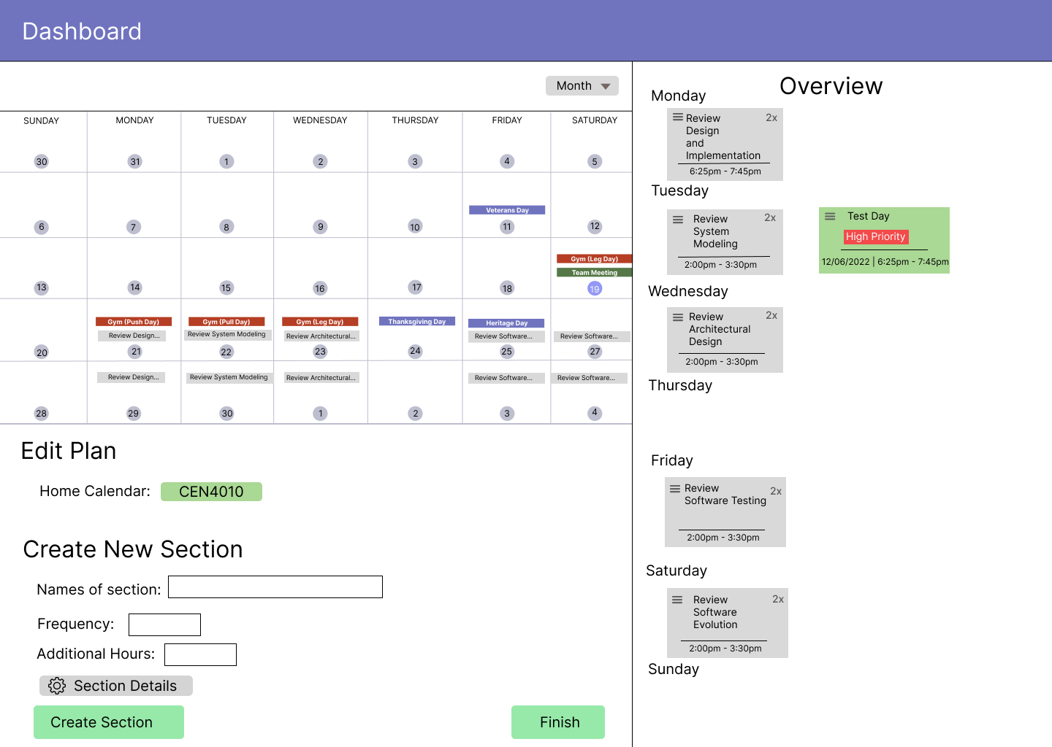

## 3.6: Rationale Management

3.6.1: Issues Addressed

* Conflicting schedule calendar design to be different from the competition.
* Developing a plan of attack on how to divide the pages of the website and layout.
* Titles and Roles for each page and section of the website.
* Choosing a platform for the collaboration to be on to host third parties.

3.6.2: Alternatives Considered

* Using communication platforms and software to engage within the website.
* Choosing between the different Software Companies and sponsors.
* Deciding on the supporters and the content that would be posted on the website.
* Microsoft, Google, Mindfulness options were made available via negotiation.

3.6.3: Decisions Made to Resolve the Issues

* Communicating via Zoom, WhatsApp, in-person meetings with third parties.
* The team decided on the specific companies to divide and share the content.
* We all volunteered and chose a position/role and titles of the different section of the website.
* We decided to use an agreement for all third-party companies that provided content.

3.6.4: Criteria Used to Guide Decisions

* Decisions were based on a majority vote an input for collaboration within the team.
* The funding and collaboration that was provided by the other companies.
* List of roles provided by the team and approved by the product owner.
* There was an agreement to have shared space and content by vote.

3.6.5: Debate Regarding Decision-Making

* What days and times to meet up for project planning.
* The content that will be used for the website.
* Debating on what content would be placed on the website.
* Which media would be the best to host the servers and content.

# **4. Implementation**

## 4.1: SCRUM Methodology

ScheduleMe was developed under the SCRUM project management framework. The team would meet twice a week, once in person and once through Zoom, to discuss app features, develop user stories and deliberate over app improvements. Below is a series of tables that display the development of a variety of the user stories and what impediments were found along the way per sprint.

**Sprint 1** - August 28 to September 10, 2022

Product Owner: Robin Obregon

Scrum-Master: Alejandro Cores

Team: 1

**Team Planning** (08/30/22)

Stories for this Sprint:

|  |  |  |  |  |
| --- | --- | --- | --- | --- |
| Story ID | Story Title | Status | Assigned To | Estimate |
| N/A |  |  |  |  |

Sprint Goal: What are items/concepts that we hoped to accomplish in this sprint?

* Organize the team and designate group roles in order to be able to start working on the project efficiently. Start pitching ideas and reach a final agreement on what the app will be.

Total Estimated Velocity: 10 hrs.

**Team Review** (09/09/22)

Stories completed in Sprint:

|  |  |  |  |  |
| --- | --- | --- | --- | --- |
| Story ID | Story Title | Status | Assigned To | Estimate |
| N/A |  |  |  |  |

Stories NOT completed in Sprint:

|  |  |  |  |  |
| --- | --- | --- | --- | --- |
| Story ID | Story Title | Status | Assigned To | Estimate |
| N/A |  |  |  |  |

Sprint Goal: Were all the sprint goals achieved?

* Yes, by the culmination of the sprint everyone in the group was set on the scheduling/mental assistance app. Moreover, all group roles were assigned and online meetings were scheduled without issue.

Total Velocity: 10 hrs.

**Team Retrospective** (09/10/22)

**What went well?**

By the culmination of the sprint, everyone in the team was willing to work on the scheduling/mental assistance application.

**What didn’t go well?**

Some team members had issues joining the latter meeting of the week, due to it taking place outside the classroom.

**How can we improve?**

Promote the usage of the team group-chat and inform members of possible complications attending meetings.

**Action Items:**

|  |  |  |
| --- | --- | --- |
| Item | Assigned To | Due on |
| Improve communication among team members | Everyone | 09/24/22 |

**Sprint 2** - September 11 to Sep. 24, 2022

Product Owner: Robin Obregon

Scrum-Master: Alejandro Cores

Team: 1

**Team Planning** (09/13/22)

Stories for this Sprint:

|  |  |  |  |  |
| --- | --- | --- | --- | --- |
| Story ID | Story Title | Status | Assigned To | Estimate |
| N/A |  |  |  |  |

Sprint Goal: What are items/concepts that we hoped to accomplish in this sprint?

* Think of a general idea of what the app would achieve and look like in real life. Appoint the app towards a certain demographic, outline a GUI, and allocate application requirements.

Total Estimated Velocity: 20 hrs.

**Team Review** (09/23/22)

Stories completed in Sprint:

|  |  |  |  |  |
| --- | --- | --- | --- | --- |
| Story ID | Story Title | Status | Assigned To | Estimate |
| N/A |  |  |  |  |

Stories NOT completed in Sprint:

|  |  |  |  |  |
| --- | --- | --- | --- | --- |
| Story ID | Story Title | Status | Assigned To | Estimate |
| N/A |  |  |  |  |

Sprint Goal: Were all the sprint goals achieved?

* Yes, by the culmination of the sprint everyone in the group was set on the scheduling/mental assistance app. Moreover, all group roles were assigned and online meetings were scheduled without issue.

Total Velocity: 20 hrs.

**Team Retrospective** (09/24/22)

**What went well?**

The team started working more efficiently and there were no issues with any meetings throughout the sprint.

**What didn’t go well?**

Not all user stories were completed as there were some difficulties reaching a consensus on certain app features.

**How can we improve?**

As a team, be more open about any potential additions to the application without changing its essence.

**Action Items:**

|  |  |  |
| --- | --- | --- |
| Item | Assigned To | Due on |
| Work on giving constructive criticism when referencing app features | Everyone | 10/08/22 |
| Finalize an outline for the GUI | Joshua | 10/08/22 |

**Sprint 3** - September 25 to October 8, 2022

Product Owner: Robin Obregon

Scrum-Master: Alejandro Cores

Team: 1

**Team Planning** (09/27/22)

Stories for this Sprint:

|  |  |  |  |  |
| --- | --- | --- | --- | --- |
| Story ID | Story Title | Status | Assigned To | Estimate |
| N/A |  |  |  |  |

Sprint Goal: What are items/concepts that we hoped to accomplish in this sprint?

* Pitch and establish features that would be implemented into the application. Moreover, adapt said features into user stories for documentation.

Total Estimated Velocity: 20 hrs.

**Team Review** (10/07/22)

Stories completed in Sprint:

|  |  |  |  |  |
| --- | --- | --- | --- | --- |
| Story ID | Story Title | Status | Assigned To | Estimate |
| N/A |  |  |  |  |

Stories NOT completed in Sprint:

|  |  |  |  |  |
| --- | --- | --- | --- | --- |
| Story ID | Story Title | Status | Assigned To | Estimate |
| N/A |  |  |  |  |

Sprint Goal: Were all the sprint goals achieved?

* Yes, a total of 12 features were pitched to the product owner. Additionally, a number of user stories have been raised for the next sprint.

Total Velocity: 20 hrs.

**Team Retrospective** (10/08/22)

**What went well?**

Everyone in the team collaborated to pitch 12 different features to the product owner.

**What didn’t go well?**

Some alterations to the SCRUM documents were not being logged properly.

**How can we improve?**

If the documentation is altered in any way outside of meeting hours, create a “ticket” by letting other group members know through the team group-chat.

**Action Items:**

|  |  |  |
| --- | --- | --- |
| Item | Assigned To | Due on |
| Implementation of “tickets” in the team group-chat | Everyone | 10/22/22 |

**Sprint 4** - October 9 to Oct. 22, 2022

Product Owner: Robin Obregon

Scrum-Master: Alejandro Cores

Team: 1

**Team Planning** (10/11/22)

Stories for this Sprint:

|  |  |  |  |  |
| --- | --- | --- | --- | --- |
| Story ID | Story Title | Status | Assigned To | Estimate |
| SM01 | Customizable Notifications | Pending | Everyone | 7 hrs. |
| SM02 | Mindfulness Tasks | Pending | Everyone | 7 hrs. |
| SM03 | Event Labeling | Pending | Everyone | 7 hrs. |
| SM04 | Event Hierarchy | Pending | Everyone | 7 hrs. |
| SM05 | Document Parsing | Pending | Everyone | 7 hrs. |
| SM06 | Plan Assistance | Pending | Everyone | 7 hrs. |

Sprint Goal: What are items/concepts that we hoped to accomplish in this sprint?

* Address all general feature user stories so that all group members can focus on their respective assigned tasks.

Total Estimated Velocity: 45 hrs.

**Team Review** (10/21/22)

Stories completed in Sprint:

|  |  |  |  |  |
| --- | --- | --- | --- | --- |
| Story ID | Story Title | Status | Assigned To | Estimate |
| SM01 | Customizable Notifications | Completed | Everyone | 7 hrs. |
| SM02 | Mindfulness Tasks | Completed | Everyone | 7 hrs. |
| SM03 | Event Labeling | Completed | Everyone | 7 hrs. |
| SM04 | Event Hierarchy | Completed | Everyone | 7 hrs. |
| SM05 | Document Parsing | Completed | Everyone | 7 hrs. |
| SM06 | Plan Assistance | Completed | Everyone | 7 hrs. |

Stories NOT completed in Sprint:

|  |  |  |  |  |
| --- | --- | --- | --- | --- |
| Story ID | Story Title | Status | Assigned To | Estimate |
| N/A |  |  |  |  |

Sprint Goal: Were all the sprint goals achieved?

* Yes, all general feature user stories were handled, allowing team members and section leaders to address any leftover requirements in the next sprint.

Total Velocity: 40 hrs.

**Team Retrospective** (10/22/22)

**What went well?**

Half of the features presented were turned into user stories.

**What didn’t go well?**

The project abstract hasn’t been updated in the last two sprints.

**How can we improve?**

Make sure that all section leaders are frequently adding new information to the abstract.

**Action Items:**

|  |  |  |
| --- | --- | --- |
| Item | Assigned To | Due on |
| Weekly abstract check-up | Everyone | 11/05/22 |

**Sprint 5** - October 23 to November 5, 2022

Product Owner: Robin Obregon

Scrum-Master: Alejandro Cores

Team: 1

**Team Planning** (10/25/22)

Stories for this Sprint:

|  |  |  |  |  |
| --- | --- | --- | --- | --- |
| Story ID | Story Title | Status | Assigned To | Estimate |
| SM07 | Social Profile Creation | Pending | Everyone | 7 hrs. |
| SM08 | Calendar Sharing | Pending | Everyone | 7 hrs. |
| SM09 | Calendar Extraction | Pending | Everyone | 7 hrs. |
| SM10 | Introduction Survey | Pending | Everyone | 7 hrs. |
| SM11 | Calendar Creation | Pending | Everyone | 7 hrs. |
| SM12 | Event Creation | Pending | Everyone | 7 hrs. |

Sprint Goal: What are items/concepts that we hoped to accomplish in this sprint?

* Finalize all user stories and create a complete rough draft of the project document.

Total Estimated Velocity: 45 hrs.

**Team Review** (11/04/22)

Stories completed in Sprint:

|  |  |  |  |  |
| --- | --- | --- | --- | --- |
| Story ID | Story Title | Status | Assigned To | Estimate |
| SM07 | Social Profile Creation | Pending | Everyone | 7 hrs. |
| SM08 | Calendar Sharing | Pending | Everyone | 7 hrs. |
| SM09 | Calendar Extraction | Pending | Everyone | 7 hrs. |
| SM10 | Introduction Survey | Pending | Everyone | 7 hrs. |
| SM11 | Calendar Creation | Pending | Everyone | 7 hrs. |
| SM12 | Event Creation | Pending | Everyone | 7 hrs. |

Stories NOT completed in Sprint:

|  |  |  |  |  |
| --- | --- | --- | --- | --- |
| Story ID | Story Title | Status | Assigned To | Estimate |
| N/A |  |  |  |  |

Sprint Goal: Were all the sprint goals achieved?

* Yes, all user stories were developed and all documentation has been finalized.

Total Velocity: 40 hrs.

**Team Retrospective** (11/05/22)

**What went well?**

Everyone in the team made a final effort to work as one and bring the project together.

**What didn’t go well?**

There were little to no issues in the last sprint.

**How can we improve?**

N/A

**Action Items:**

|  |  |  |
| --- | --- | --- |
| Item | Assigned To | Due on |
| N/A |  |  |

## 4.2: Daily Standups

**Sprint 1**

Team Member 1:Robin Obregon

**What I did Yesterday:** Research project ideas individually.

**What I am going to do Today:** Review possible project ideas with my team.

**Impediments:**Lack of time due to other classes.

Team Member 2: Alejandro Cores

**What I did Yesterday:**Research any possible implications surrounding the pitched projects.

**What I am going to do Today:**Organize all scrum documents and verify that all team members are on a proper schedule.

**Impediments:** N/A

Team Member 3: Ivan Najera

**What I did Yesterday:** Met with teammates.

**What I am going to do Today:** Develop stories.

**Impediments:** Scheduling meetings.

Team Member 4: Joshua Gomez

**What I did Yesterday:** Met with teammates.

**What I am going to do Today:** Develop stories.

**Impediments:** N/A

Team Member 5: Carlos Ramos

**What I did Yesterday:**Met with team members, research possible features on proposed projects.

**What I am going to do Today:**Go over my research and present the features I thought of and the requirements of those features to the team.

**Impediments:** Unsure on the requirements needed for certain features.

Team Member 6:  Brian Rodriguez

**What I did Yesterday:** Participate in planning on when the team would meet up.

**What I am going to do Today:** Participate in creating the stories for the first sprint. Finish writing a portion of the introduction for the project proposal. Help finalize the project idea. Aid assigning group roles.

**Impediments:** N/A

**Sprint 2**

Team Member 1: Robin Obregon

**What I did Yesterday:** Look into features needed for a scheduling application.

**What I am going to do Today:** Review how to make the app unique with my team.

**Impediments:**N/A

Team Member 2: Alejandro Cores

**What I did Yesterday:**Look into other scheduling applications and assess possible improvements.

**What I am going to do Today:** Evaluate if the software would be more efficient as a website or a mobile application.

**Impediments:** N/A

Team Member 3: Ivan Najera

**What I did Yesterday:** Met with teammates.

**What I am going to do Today:** Begin verification process of items.

**Impediments:** Pending items on missing input from team.

Team Member 4: Joshua Gomez

**What I did Yesterday:** Checking scheduling applications alongside improvements to make it unique.

**What I am going to do Today:** Work together to come up with ways to make the application helpful.

**Impediments:** N/A

Team Member 5: Carlos Ramos

**What I did Yesterday:** Review other scheduling applications requirements and make notes on key factors.

**What I am going to do Today:** Review my proposed requirements and compare them to other applications  already implemented.

**Impediments:** N/A

Team Member 6: Brian Rodriguez

**What I did Yesterday:** Met with teammates.

**What I am going to do Today:** Finish writing a portion of the requirements section for the project proposal. Help finalize the project idea.

**Impediments:** N/A

**Sprint 3**

Team Member 1: Robin Obregon

**What I did Yesterday:** Researched more into scheduling apps, as well as mental wellness apps for features.

**What I am going to do Today:** Meet with teammates to discuss features, begin circling in features we will include.

**Impediments:**N/A

Team Member 2: Alejandro Cores

**What I did Yesterday:** Discuss possible features for the app among team members.

**What I am going to do Today:** Make sure that all scrum documentation up to the third sprint is up to date.

**Impediments:** N/A

Team Member 3: Ivan Najera

**What I did Yesterday:** Met with teammates.

**What I am going to do Today:** Verify the scrum process and documentation accordingly.

**Impediments:** N/A

Team Member 4: Joshua Gomez

**What I did Yesterday:** Meet with the team to discuss any features that we can use for the application.

**What I am going to do Today:** Checking that the scrum documentation are up to date.

**Impediments:** N/A

Team Member 5: Carlos Ramos

**What I did Yesterday:** Discussed features for proposed application.

**What I am going to do Today:** Continue research on key requirements for proposed application.

**Impediments:** It may be difficult to implement our application differently from other made applications with reputable companies.

Team Member 6: Brian Rodriguez

**What I did Yesterday:** Met with teammates.

**What I am going to do Today:** Do research on any potential requirements missing.

**Impediments:** N/A

**Sprint 4**

Team Member 1: Robin Obregon

**What I did Yesterday:** Research requirements and design for our app.

**What I am going to do Today:** Meet with team and discuss requirements and design.

**Impediments:**N/A

Team Member 2: Alejandro Cores

**What I did Yesterday:** Proposal formatting.

**What I am going to do Today:** Begin to translate all features into user stores.

**Impediments:** N/A

Team Member 3: Ivan Najera

**What I did Yesterday:** Meet with team.

**What I am going to do Today:** Quality check stories.

**Impediments:** Scheduling constraints.

Team Member 4: Joshua Gomez

**What I did Yesterday:** Discussing with the team about the design and any possible features for the app.

**What I am going to do Today:** Working together on the design.

**Impediments:** Scheduling**.**

Team Member 5: Carlos Ramos

**What I did Yesterday:** Team met with professor for further guidance on potential features.

**What I am going to do Today:** Create a proposal for the requirements brought forward by the professor. (Mood Music Player)

**Impediments:** Arranging valuable meeting times with team, due to the team having other schoolwork.

Team Member 6:  Brian Rodriguez

**What I did Yesterday:** Looked over UML representations of the application.

**What I am going to do Today:** Designed database schema.

**Impediments:** Difficulty implementing the application into

**Sprint 5**

Team Member 1: Robin Obregon

**What I did Yesterday:** Research requirements and design for our app.

**What I am going to do Today:** Meet with team and discuss requirements and design.

**Impediments:**N/A

Team Member 2: Alejandro Cores

**What I did Yesterday:** Finalized the implementation section of the proposal.

**What I am going to do Today:** Proofread documentation.

**Impediments:** N/A

Team Member 3: Ivan Najera

**What I did Yesterday:** Meet with team.

**What I am going to do Today:** Quality check stories.

**Impediments:** Scheduling constraints.

Team Member 4: Joshua Gomez

**What I did Yesterday:** Discussing with the team about the design and any possible features for the app.

**What I am going to do Today:** Working together on the design.

**Impediments:** Scheduling**.**

Team Member 5: Carlos Ramos

**What I did Yesterday:** Team met with professor for further guidance on potential features.

**What I am going to do Today:** Create a proposal for the requirements brought forward by the professor. (Mood Music Player)

**Impediments:** Arranging valuable meeting times with team, due to the team having other schoolwork.

Team Member 6:  Brian Rodriguez

**What I did Yesterday:** Revised sequence diagrams.

**What I am going to do Today:** Help finalize a PowerPoint presentation

**Impediments:** N/A

# **5. Verification**

## 5.1: Verification Definition

Software verification, also known as software quality control, is an essential process in software development. It involves the task of checking if the software produced meets the requirements and specifications of the customer. The goal of software verification is to ensure that there are no bugs or issues present in the program. To achieve that goal, the team needs to constantly document everything during the whole software engineering process.

## 5.2: Verification Process Introduction

The team examined the products to verify whether they fulfill the phase's criteria. Then, we checked if the product is constructed according to the requirements and design specifications. We verify if accessing the site works from multiple browsers and static tests are also included. Reviewing and inspecting the site contents and buttons are a way we walkthrough with the verification process. Ensuring that the site is properly accessible from the endpoint user’s view.

## 5.3: Test Case Description/Demonstration

* The Login Page test is to make sure that the user can log in to the website to see if all the components are working properly.
* The Dashboard test is to make sure that the user has access to the utilities and features, they can retrieve their events and see if all the components are working properly within their calendar.
* The Calendar Page test is to make sure that the user can see all the pending items. Along with another option for them being able to modify part of or all the components within the calendar, including external features.
* The Event Manipulation/Settings Page will modify specific events and change notification settings for the date chosen by the user.
* The Mindfulness Page will provide access to select/sign-up and be able to search for whatever they are interested in for relaxation/stress relief. This will be used for break purposes in between sessions.
* The Social Profile Page test is to see if the user can click on their profile and update their personal information. They will be able to connect with other users and site calendars to share specific events.

## 5.4: Traceability Between the Test Cases/Plan and Requirements

|  |  |  |  |
| --- | --- | --- | --- |
| Test Case Scenario | Test Case Steps | Test Case Requirements | Test Case Status |
| Login Page Functionality | 1. Access website  2. Enter username  3. Enter password  4. Click login button | When a valid username and password is input, the login attempt is successful. | Pass |
| Dashboard Functionality | 1. Login  2. View Dashboard  3. Select upcoming events  4. Choose event | When a user selects to view upcoming events. | Pass |
| Calendar Functionality | 1. Login  2. Navigate to Calendar  3. Select specific event  4. Select time frame | When a user selects a day/week/month within the calendar. | Pass |
| Event Manipulation/ Settings Functionality | 1. Login  2. Navigate to Settings  3. Select setting to modify  4. Modify preference | When a user changes the event date/time and notification preference. | Pass |
| Mindfulness Functionality | 1. Login  2. Navigate to Mindfulness  3. Select option to run  4. Login to feature selected | When a user is redirected for options to choose from for their break/relaxation session. | Pass |

# **6. Lessons Learned**

The process of creating software from scratch is one of the most important things one can learn in this field, and it has served a major lesson on the importance of working together. Besides learning the various methods, terms, and processes behind software engineering, which we will go over later, this course and project were about learning how to manage yourself and others within a team setting. Managing the individual lives of 6 different people is difficult in any setting, even more so when these 6 people have different school schedules, work schedules, and family schedules. Communication was the key to managing all of this, whether it be in class time, on Zoom, or through WhatsApp, our team did not go a day without checking in on each other. Furthermore, we were all very clear from the beginning with the roles we would each assume, which helped us push through this project in a manner which was a lot easier for everybody.

To delve deeper into the specifics of how we approached this project, we look into the organizational structures we used to streamline the process of software development. We used SCRUM methodology, known for its facilitation of approaching a large-scale project by breaking it down into smaller pieces for each member to individually tackle. This gave each group member a clear vision of their role for this project and allowed us to work independently while still contributing to our larger goal. There was also the creative side of development. We collaborated to come up with our final idea of a simple scheduling app with a focus on helping students with their mental health. We looked at each other and found some similarities in our different situations and saw a need for such an idea. This gave us perspective into looking for target audiences and markets when brainstorming ideas for a project. Once we had that under control, we had to move forward with our vision for this project. Using FIGMA, we created prototypes to help visualize what this project will look like once fully implemented. Using these organizational and creative processes was much different from group assignments we have worked on in the past. There is a completely different level of planning and coordination when it comes to software development. This experience will help shape how we approach projects and assignments in our pursuit of becoming masters of software development.